3D PAWS Evaluation
Adana Site Visit: Maintenance and Condition Assessment. 1/15/2024
Tasks conducted:
Dismantled and cleaned the 3 rain gauges.
Reassembled the rain gauges and added a rain gauge stabilizer to each station.
Dismantled and cleaned the 3 radiation shields.
Changed the temperature, pressure and humidity sensors in stations 1 and 3.
Replaced the HTU 21D humidity sensor with the SHT 31D sensor in stations 1 and 3.
Replaced the anemometer rotor on station 2.
Downloaded all data from the Particle Argon SD cards.
- Overall Condition
All three stations showed signs that they had received little maintenance since installation 14 months prior (original installation was Nov 14, 2022). The rain gauges in particular were dirty, although they were all level. The anemometer on station 2 was binding and closer inspection showed corrosion of the bearing; the remaining anemometers and wind vanes were all spinning freely; the inside of the data logger boxes were clean and dry. The radiation shields were somewhat dirty and the closed leaves on two of the stations had broken inner tubes, although this did not affect their ability to function.
- Rain Gauges
Station 2 rain gauge was missing both the horizontal and vertical screens, so not surprisingly, the tipping bucket was particularly dirty.
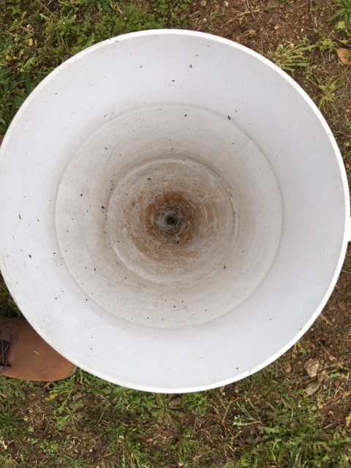
Photo 1. Station 2 rain gauge before dismantling.

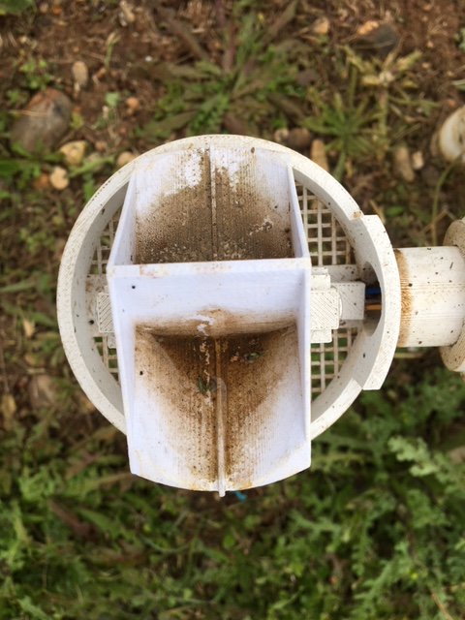
Photo 2. Station 2 bucket before cleaning
Station 1 had both horizontal and vertical screens in place but inexplicably, there were two pebbles with a diameter of approximately 5mm stuck in the orifice of the funnel, below the vertical screen.
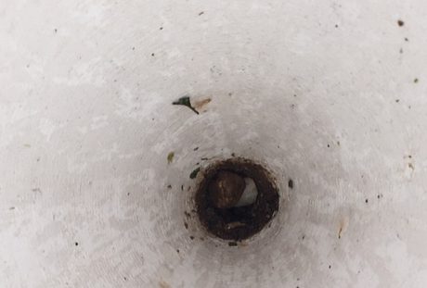
Photo 3. Station 1 funnel showing pebbles

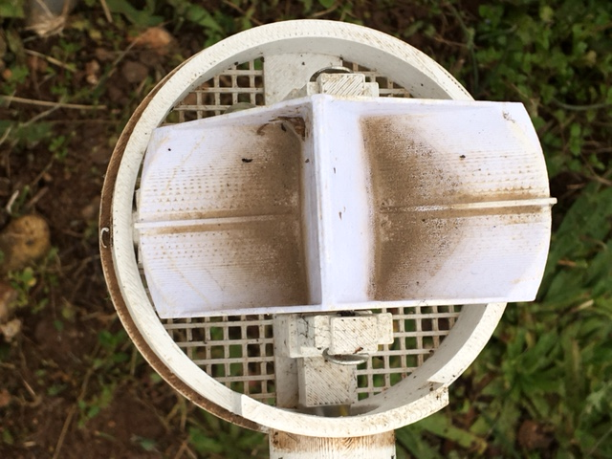
Photo 4. Station 1 bucket before cleaning
After cleaning, all three rain gauges appeared to be in good condition with no mechanical issues. All three were also found to be level.
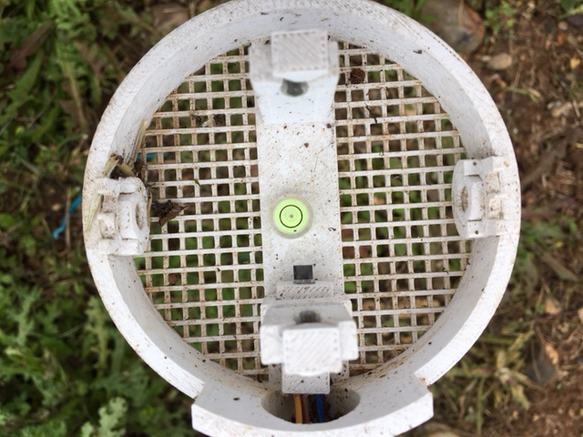
Photo 5. Station 2 level
A soft toothbrush was used to clean the funnel, the screen and the bucket of all three gauges; all components cleaned up well and showed no significant deterioration.

- Adding Rain Gauge Stabilizers
All three gauges were fitted with the new rain gauge stabilizer after they were reassembled. The stabilizers prevents loss of level due to rotation of the rain gauge about the leveling joint, which has been observed at some installations.
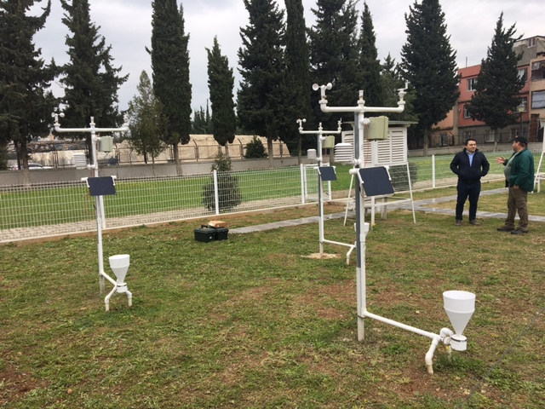
Photo 6. Gauges with Stabilizer
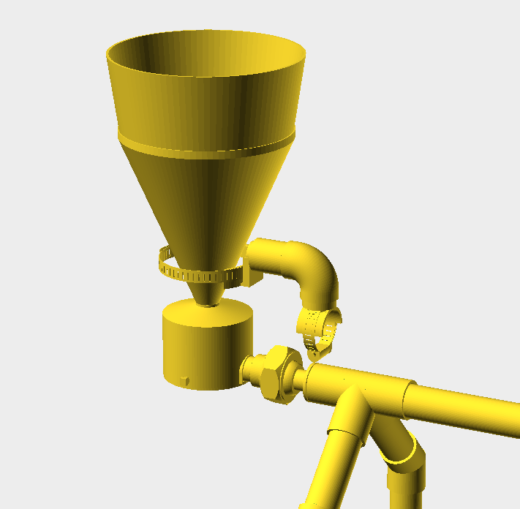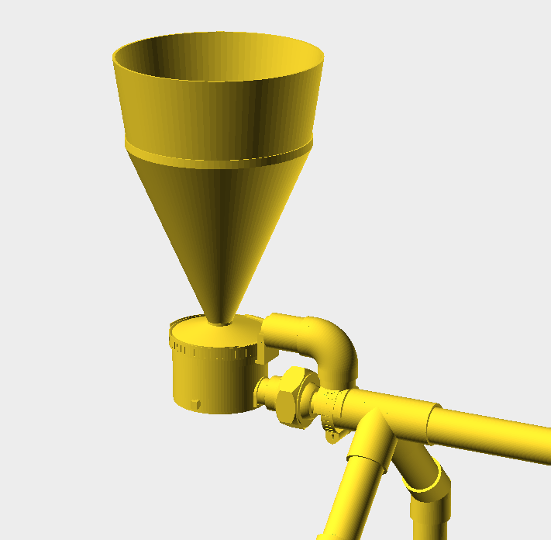
Illustration 1. Details of the Rain Gauge Stabilizer
- Radiation Shields
The following photos are of Station 1 radiation shield but they are representative of the condition of all three shields:
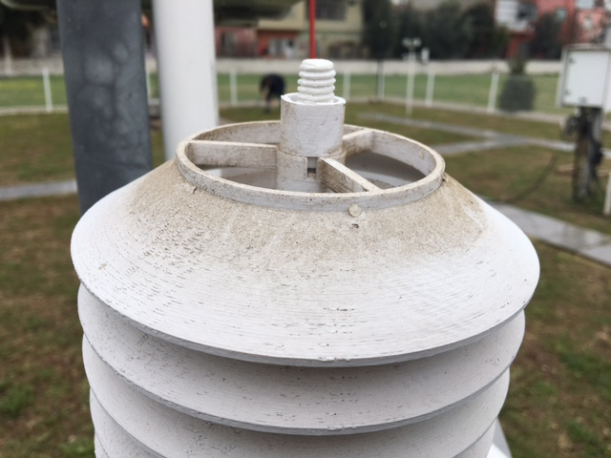
Photo 7. Radiation shield showing broken tube of closed shield
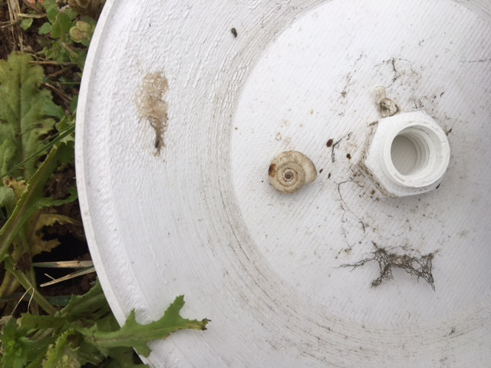
Photo 8. Radiation shield occupant
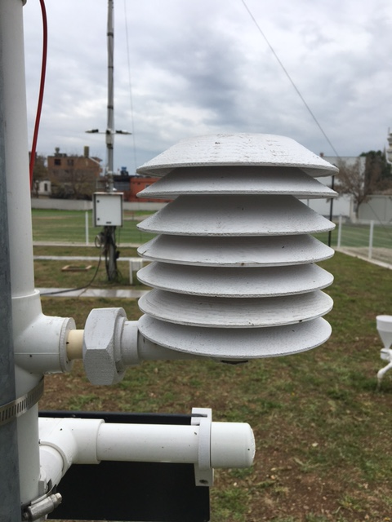
Photo 9. Reassembled radiation shield
A soft toothbrush was again used to clean the radiation shield components; all components cleaned up well and showed no significant deterioration or discoloration.
- Radiation Shield Harnesses
The original radiation shield harness included one MCP 9808 temperature sensor, one BMP 280 pressure/temperature sensor and one HTU 21D relative humidity/temperature sensor. A recent rudimentary comparison of data from the three sets of sensors indicated that all components were still operating as expected. An inspection of the components found that they were somewhat dirty but showed little or no signs of corrosion. All the cables and connectors also appeared to be in good condition.
Given the logistical issues of conducting maintenance and that 18 months might be considered a reasonable service life for low cost sensors, it was decided that new sensors should be installed in two of the three shields, while one shield (Station 2) retained the original sensors as a bench mark and longevity test. In addition, the HTU 21D humidity sensors in Stations 1 and 3 were replaced by SHT 31D sensors. The SHT 31D is the new standard sensor for the 3D PAWS station.
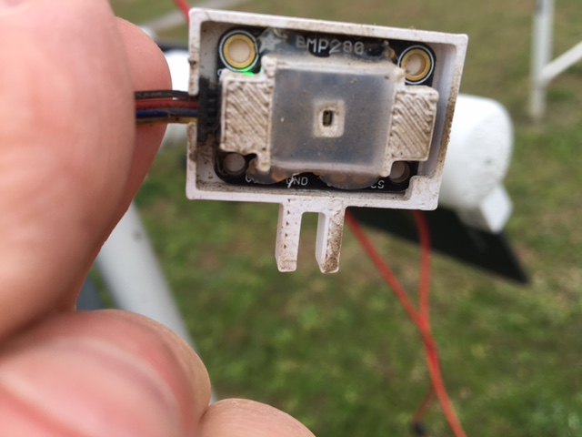
Photo 10. Dirty pressure sensor
- Anemometer rotor replacement
The rotor on station 2 anemometer was found to have a corroded bearing, so the entire rotor assembly was replaced.
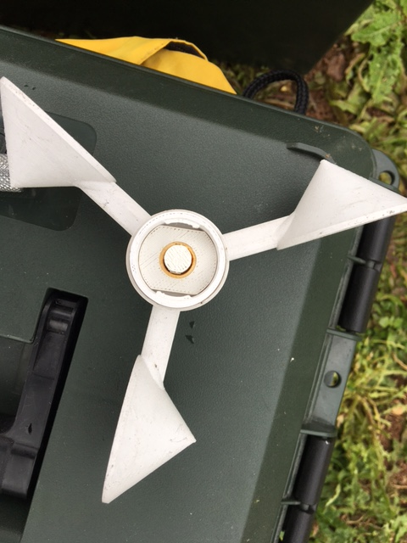
Photo 11. Anemometer bearing corrosion

- Data Download
All data recorded by the 3D PAWS stations are saved to an on-board SD card as a backup in case of loss of the communications link. All data that had been saved to the SD card during the last 17 months was downloaded from the Konya stations during the maintenance visit.

